Project Proposal – Sleeping habit forming alarm

**Title:** Sleeping habit forming alarm

**Member Info**: Dazhi Li (NetID: dazhili ; StudentID: 2400330)

**Project Description**:

Nowadays, people are getting less sleep due to heavy work or they are over entertaining themselves at night to release their pressure. If people get sleep before the weekend or the day when they do not have to get up early is okay. However, when there is an early meeting at office or class at school, people become zombie at work, which results a bad day.

What I am going to propose to solve this problem is developing an alarm clock which could help the user to form a better sleep habit. If a user is going to get up early next morning, user could set an alarm via his own phone. The alarm clock should have no button on it. Once a getting up time is ready, the cloud computation will build a sleep schedule for the user. This schedule leaves a user-defined time or system recommended time for user to sleep this night. Before going to bed, this system will warn the user to get a shower or anything else before sleeping via the phone. Once the sleep time comes, the alarm clock will monitor if there is a human on the bed. If not, notifications will be sent to user by an interval of 10 minutes to push our user for sleep. And my alarm clock should record the late time of the user and store it for later recommended sleep schedule usage. After a whole night of sweet sleep, the alarm clock will keep alarming until the user get out of the bed. Since there is no button on the alarm clock, this is unstoppable until the user to get up. This makes sure that our user will not be late for any important things. The whole process are shown in the figure below.

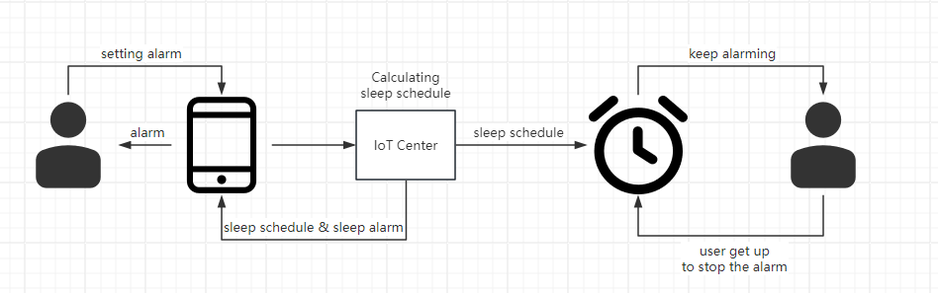

Moreover, if time allowed, I want to integrate with other functions like sleep gesture and sleep snoring detection on my smart alarm clock. This will help generate weekly/daily sleep report for improving the users’ sleep habit.

**Expected Challenges:**  I expected the hardest part is sleeping status detection. If time allowed, sleeping gesture detection is also very hard. I think I am going to rely on some machine learning techniques on image processing to detect whether our user is on bed or not. Moreover, I think the device communication between my smart alarm clock, IoT center and user’s phone is quite challenging. I should design an efficient and reliable communication network for getting the whole process running correctly. Thirdly, I think developing user end mobile phone app is quite time consuming. Make a better human-machine interface is always important in a project.

**Estimated Time Schedule:**

Now~10.30: Equipment renting, related knowledge study and midterm presentation

10.30~11.20: Implementation of whole system, including coding, testing and hardware assembling

11.20~11.30: Final project paper writing

11.30~12.1: Recode project demo

12.1~12.4: submit all the project related material and returning equipment